|  |
| --- |
| Circle Language Spec: System Objects |

## Aspect-In-A-Triangle

An aspect is represented by a triangle containing system commands:

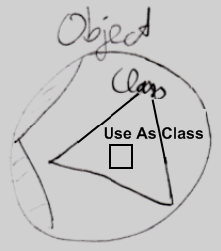

It was a design choice to have system commands placed inside a triangle, that represents the aspect, because it does not always look best to explicitly qualify each Class command with ‘Class . ’ So you can directly call the Use As Class command and not use something like:

Class . Use As Class

Class . Use Object As

Object . Use As Class

That last one *looks* fine, but places a class-related action inside the Object aspect, which you do not want, because you want to keep all commands that apply to the Class aspect together under the Class aspect.

All-in-all: this is a design choice.